**Week 11**

*Describe the data of your project and the visualizations you plan to use. Attribute anything you plan to use from somewhere else. Report the errors and challenges you are facing.*

**Data I plan to use:**

* deforestation trend globally over the years:
  + <https://fra-data.fao.org/assessments/fra/2020/WO/home/overview>
  + <https://ourworldindata.org/deforestation>
* drivers/causes of deforestation + countries’ share of deforestation:
  + Brazil is responsible for most of the world’s deforestation
  + Main causes of deforestation are agriculture and cattle ranching
  + <https://ourworldindata.org/drivers-of-deforestation>
  + <https://www.worldwildlife.org/magazine/issues/summer-2018/articles/what-are-the-biggest-drivers-of-tropical-deforestation#:~:text=Beef%20production%20is%20the%20top,and%20fourth%20biggest%20drivers)%20combined>
  + <https://research.wri.org/gfr/forest-extent-indicators/deforestation-agriculture>
* Living Planet Index:
  + LPI shows that biodiversity has decreased drastically over the years, and humans are the main cause of this loss, especially the change in land use (clearing of forests)
  + <https://www.statista.com/chart/17122/number-of-threatened-species-red-list/>
  + <https://www.livingplanetindex.org/latest_results>

**Visualizations I plan to use:**

* living planet index(line):
  + <https://www.livingplanetindex.org/latest_results>
  + planning to use only the first two columns and every row (
  + the living planet index is a measure of the state of the world's biological diversity based on population trends of vertebrate species from terrestrial, freshwater and marine habitats (<https://www.livingplanetindex.org/> )
  + biodiversity loss is mainly caused by deforestation and climate change
  + latin america and the caribbean, where brazil is, has seen a decrease of 94% of biodiversity (<https://livingplanet.panda.org/en-US/> )
* causes of deforestation(bar):
  + <https://ourworldindata.org/drivers-of-deforestation>
  + 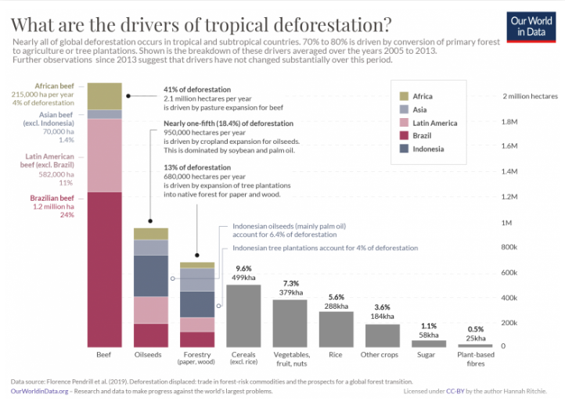
  + Planning to make only the first two bars “beef” and “oilseeds” a stacked bar plot
* countries’ share of deforestation(doughnut):
  + <https://ourworldindata.org/drivers-of-deforestation>
  + 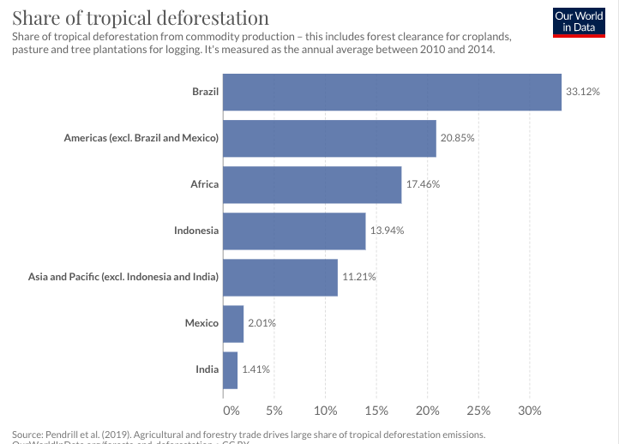

* Reduction of global forested area overtime (interactive bar chart using slider)
  + When slider moves, bar chart changes

**Challenges and errors faced:**

| Challenges/errors | Line number | File name |
| --- | --- | --- |
| Could not change the font for the “click koko the koala” button -> eventually realized that it was due to unmatching ID names used | 17  26-31 | Index.html  css |
| There is a weird padding on the right throughout the website | - | - |
| Not sure how to make the first background image fill the entire screen. There are currently margins around the image. | 14  1-4 | Index.html  css |
| Button for “increase in demand for beef” image change: Not sure how to make it such that when I click the button, image changes and when I click again, image changes back | 102-108 | index.html |
| For the first clickable element, “click on Koko the koala”, parts of the first and second containers were also clickable, I thought that it did not look very clean -> looked at the developer tools under “elements’ to check my divs and realized that it was an image issue. The image was overlapping between the first and second divs | 16  34-45 | Index.html  css |
| The images need to be clicked twice before the text appears whenever the page is reloaded | 75,81,86  199-224 | Index.html  main.js |

**Progress made:**

| Progress | Line number | File name |
| --- | --- | --- |
| Changed the cursor to pointers for all clickable elements | 43,86,168,275,347,351,355 | css |
| Added more information | 27-40,73-90 | index.html |
| Used tables to put more information about the impacts of deforestation on biodiversity (golden lion tamarin, jaguar, spix’s macaw) | 73-90  230-244 | Index.html  css |
| Added functions (onclick, text appears) for the above table | 75,81,86  199-224 | Index.html  main.js |
| Added typewriter effect for “so…why should I care?” | 111  227-243 | Index.html  main.js |